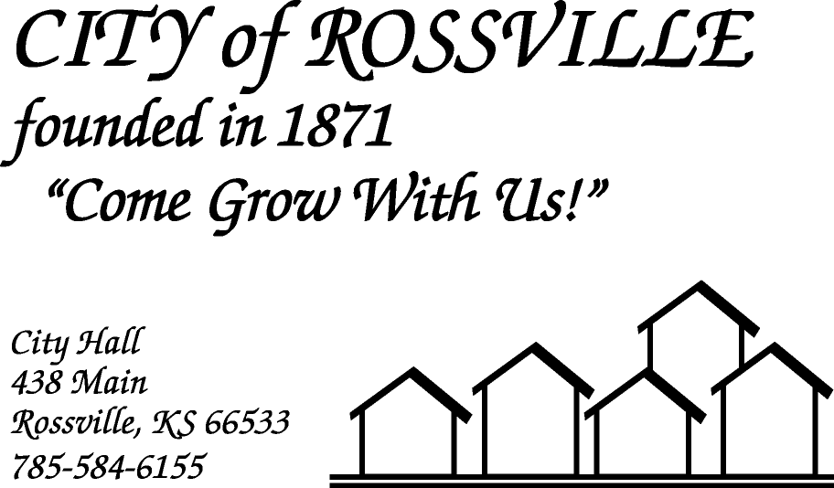

**AGENDA**

**MONDAY**

**JULY 20, 2020**

***AGENDA SUBJECT TO CHANGE***

7:00pm MINUTES

BILLS

ADOPT AGENDA

7:05 pm STACY LANGE

Dance outside at American Legion

7:25 pm COUNCIL REPORT

7:35 pm UTILITY DEPT REPORT/BUSINESS

7:45 pm POLICE DEPT REPORT/BUSINESS

7:55 pm OLD BUSINESS

2021 Budget

Solid Waste Management Committee

8:20 pm NEW BUSINESS

Rossville Rec Commission request for money

MDA Hog Ball Tournament Cancelled

8:30 pm ADJOURN

This meeting will be conducted using ZOOM..

MEETING ID: 874 4347 3552

PASSWORD: 283712